Diary No.1

Week 2: On-site

Topic: Thinking of an original game idea for making employability skills fun to learn

Date: 02/10/2020

Team members: Reece Taylor, Jamie Smith, Spas Spasov, Ali Noorani (myself).

Before the teams were made, the class learned about the different famous people in the gaming industry, some who had done TED talks, others who had a definition of what a game is. “A game is a problem solving activity approached with a playful attitude”.

The lecturer then carried on talking about the idea of meaningful play, and the factors involved in meaningful play.

The factors involved: -

* Descriptive: The systems reaction to the action of the player.
* Evaluative: The relationship between the player and the game/ system. There can be two different types of relationships between them:
* Discernible: Letting the player know what happened because of their actions. E.g. player collecting a star and the game telling them that a new door/ path has opened up because they collected the star.
* Integrated: An action the player did, plays out a role immediately or later in the game. E.g. Collecting a med-kit which replenishes their health immediately. Or flicking a lever/ pressing a button that opens a secret path.

He then continued to talk about the idea of “a magic circle”, by Huizinga, which is the space where the game takes place. A place where all the ‘magic’ or actions happen or take place. He also talked about the type of attitude, Lusory, needed to play or enter the game. A lusory attitude refers to a type of attitude where the player inhabits itself into this illusionary world of unbelievable entities such as elves, guardians of the world, etc. Even within this imaginary, illusive and immersive world, the player must accept the rules and limitations set out by the game in exchange for the pleasure it gives.

After the talk, the team was assigned a task.

The team was tasked to think of an original game idea that would allow players to learn employability skills in a fun way.

The team set out by collecting ideas from each member about what game they thought of. The team all had a similar idea of a card game of question and answers, where the employer would be asking questions written on the cards the employer had, and the second player would be the employee, who would have the answer cards with the answers to the questions the employer had. The win condition was to answer all of the questions correctly and gain points. If the employee answered the questions incorrectly, the employee would lose points, unless the employees point count was 0. There was where the first error occurred. What are the points worth? Do the points bring anything new to the game? So, the team came up with the idea to use the points to buy skills that would help the employee answer the questions better. The employee could spend his points to increase his communication skills, or their team working skills to better themselves. This way, a hierarchy system was build. The employer starts out with easy questions about easier to get skills, such as time management skills, communication skills and team working skills. As the employee passed the level. The difficulty of the questions also increased, however with the points system the employee could use them wisely on different skills to upgrade their answers as well, to make it easier to pass the next level.

The game idea was good; however, it was lacking on the player action side and the chance side. The players’ actions was lacking because the only task or action the player was doing was answering questions using cards. There was no other task. The employer had an even lacking action. They only had to ask questions. This made it not fun for the player playing as the employer. The player would soon get bored of the game, whereas the employee would be having fun spending their hard earned points to upgrade their skills making this a very one sided game. In terms of the chance mechanic, there was no actual chance or luck involved in the game, or not that the team knew of. This made the game boring to play.

As the team liked the idea of having a points, more than one player and fun for everyone, they decided to make a board game, using money as points, to teach players the importance of money and how it can run out if spent unwisely, A board to show the skills the employers are looking for and a way to make the game challenging and fun for everyone playing. The team then decided to use books as skills and knowledge. The books could teach employees fundamental skills the employers are looking for. The team did not want to overload the board with too many skills, and hence they decided to reduce the number of skills to 8, to make the board lighter to look at and easier and faster to play. If they did put in the extra skills, there would be more rules created, and the rule/ restriction to fun ratio would be unbalanced hence making the game not fun.

The team then played the game in their minds and ended up with their first problem. How the player was going to move. They decided on a chance system of casting a die to determine how many spaces the players could move forward. The next problem was, how the player was going to buy the books is the player did not have any money to begin with? And that question popped up another question of how the player was going to gain money, if they are spending it all on ‘A’ amount books when there are ‘B’ amount of books. The answer to those questions made a few new rules. The first rule was that, at the start, the players would get ‘C’ amount of money to spend and as they passed the ‘Start’ block shown in Figure 1 the players would get ‘C’ amount of money each time. For the problem of how the player was going to gain extra money, the team decided to introduce a trade/ bartering system where the players could trade money for books owned by other players. This would not let the player with the money buy the book from the original owner; instead, it would allow the player with money to loan the book out from the player to read. Another rule that was introduced was the trading of books. If player 1 has ‘book 1’ (N) of skill (E), they could trade it with player 2 who has ‘book 3’ (O) of skill (K). The colours representing different skills as labelled in Figure 1. Of course, the trading/ bartering system could only be done when the player wanting to buy/ trade is standing on the spot on the board where the book in question is.

With 8 different skills, the board still looked heavy, so the team decided to introduce blank spots where the person would get free time to read the book. Each book having one turn complete read time, where the player could move, but not buy the books they landed on.

As the team reviewed the game, they thought the game sounded and looked a lot like monopoly.

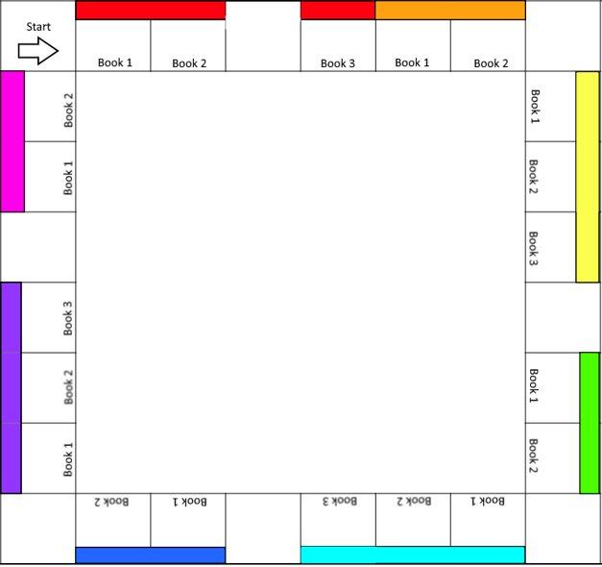The end goal of the game was to gain as much knowledge from the books as possible and collect as many books as the players could. The player with the highest knowledge and book count, would win and carry on to become the employed one out of the players. This teaches the players that hiving more knowledge and skill than the other participants does help secure a job.

(J)

(E)

(N)

(F)

(M)

(I)

(K)

(H)

(G)

(O)

(L)

Figure 1. (E) Skill: Teamwork. (F) Skill: Time Management. (G) Skill: Communication. (H) Skill: Project Management. (I) Marketing. (J) Skill: Coding. (K) Skill: Problem Solving. (L) Skill: Game Engine Knowledge. (M) Start. (N) Book 1 of the red skill. (O) Book 3 of the purple skill.

Once the presentation of the game was ready, the team presented and did good.

Further reading for secondary research:

* Brenda Braithwaite, Challenges for Game Designers, pp 69-81.
* Jesse Schell, The Art of Game Design, pp 1-74.